Support Information

## Methods

**Study Population**

In this cohort study three groups of adult participants were enrolled (aged ≥18 years), UC (n = 31), CD (n=39), and healthy individuals (n= 49) as a control group. A healthy individual was marked as such if they did not report having a GI disorder. Detailed information regarding the participant's demographics, lifestyle, and disease state were also collected, including age, sex, smoking habits, diet, alcohol consumption, supplements, the severity of the disease, and current and past medical and surgical treatments. (Supplemental Table S1)

**Samples Collection**

Fecal samples were collected at the Department of Gastroenterology at Soroka Hospital and from healthy volunteers from Ben Gurion University. They were stored in 50 mL falcon tubes at -80 ℃ until further treatment.

**Metabolite Extraction and LC-MS/MS Analysis**

Collected fecal samples underwent untargeted and targeted metabolomics using liquid chromatography-tandem mass spectrometry (LC-MS/MS). A small amount was transferred from each sample to an Eppendorf tube to analyze the samples. The new samples (i.e., in the Eppendorf tube) were frozen in liquid nitrogen and freeze-dried using a lyophilizer for 24 hours. The dry matter was weighed and suspended in cold MeOH/H2O (1:1 v/v ratio) at a   
49 mg/mL concentration and stirred for half a minute. After that, the samples were loaded into a centrifuge and spun at 4˚C, for 10 min, at 10,000 g. The supernatant was collected, and a mixed sample was used as a quality control (QC). The samples were examined by using an UltiMate 3000 UHPLC+ focused LC-MS system (Thermo Scientific™) with 2.6 μm (100 x 2.1 mm) C18 Accucore™ UHPLC column (Thermo Scientific™), followed by Q Exactive™ Focus Hybrid Quadrupole-Orbitrap™ Mass Spectrometer (Thermo Scientific™) analysis. The run conditions were a flow rate of 0.4 mL/min, with the composition of solvent A being 99.9% water and 0.1% formic acid, solvent B being 99.9% acetonitrile, and 0.1% formic acid. The gradients started with 90%:10% A:B for 2 min. After 13 min, the gradient increased to 10%:90% A:B and stayed in this composition until 17 min. The gradient changed to 90%:10% A:B until 20 min and was maintained until 22 min. The QC was added between every ten samples.   
[ADD the tune file conditions]

Metabolomics Data ProcessingThe MS analysis was conducted in positive ionization mode. All MS data were examined by freestyle and Xcalibur software (Thermo Scientific™). Following the initial examination, the raw files were converted to .mzML files by using the open-source program MSconvert9. Then, all the files were processed by MZmine3.9.0 using the batch mode with parameters in supplementary. The .mgf output file from the MZmine3.9.0 was uploaded to the Global Natural Product Social Molecular Networking (GNPS, http://gnps.ucsd.edu), a community-based online platform created and managed by the Dorrestein Lab. In the GNPS, feature-based molecular networking (FBMN) and more comprehensive analysis with MolNetEnhancer, an in silico tool within the GNPS ecosystem, was created.   
Utilizing the quantification table output from Mzmine3.9.0, relative comparison between the HC and the IBD patients’ groups.

**Table S2** Demographic and Clinical Characteristics. Data presented as mean ± standard deviation. N/A: Not applicable. P-values were calculated using the Chi-square test for categorical variables and Student's t-test or ANOVA for continuous variables as appropriate.

|  |  |  |  |  |  |
| --- | --- | --- | --- | --- | --- |
| **Category** | **Characteristic** | **HC (n=49)** | **UC (n=31)** | **CD (n=39)** | **P-value** |
| **Demographics** |  |  |  |  |  |
|  | Age (years; mean ± SD) | 34.2 ± 9.8 | 36.5 ± 11.2 | 36.8 ± 10.5 | 0.42 |
|  | Age range | 19-58 | 22-70 | 20-65 | - |
|  | Male n (%) | 25 (51.0) | 16 (51.6) | 13 (33.3) | 0.18 |
|  | Female n (%) | 24 (49.0) | 15 (48.4) | 26 (66.7) | - |
| **Clinical Characteristics** |  |  |  |  |  |
|  | Disease Duration (years; mean ± SD) | N/A | 8.2 ± 6.4 | 9.1 ± 7.2 | 0.56 |
|  | Current Smoker n (%) | 7 (14.3) | 3 (9.7) | 5 (12.8) | 0.84 |
|  | Former Smoker n (%) | 5 (10.2) | 4 (12.9) | 6 (15.4) | - |
|  | Never Smoker n (%) | 37 (75.5) | 24 (77.4) | 28 (71.8) | - |
| **Disease Activity** |  |  |  |  |  |
|  | Mayo Score (mean ± SD) | N/A | 6.6 ± 2.8 | N/A | - |
|  | Calprotectin μg/g (mean ± SD) | N/A | 285 ± 156 | 312 ± 178 | 0.48 |
| **Dietary Habits** |  |  |  |  |  |
|  | Special Diet n (%) | 12 (24.5) | 15 (48.4) | 22 (56.4) | <0.01 |
|  | Gluten-free n (%) | 3 (6.1) | 5 (16.1) | 8 (20.5) | 0.03 |
|  | Lactose-free n (%) | 4 (8.2) | 6 (19.4) | 9 (23.1) | 0.02 |
|  | Other dietary restrictions n (%) | 5 (10.2) | 4 (12.9) | 5 (12.8) | 0.89 |
| **Supplements** |  |  |  |  |  |
|  | Any Dietary Supplements n (%) | 15 (30.6) | 18 (58.1) | 25 (64.1) | <0.01 |
|  | Vitamin D n (%) | 8 (16.3) | 12 (38.7) | 15 (38.5) | 0.02 |
|  | Iron n (%) | 3 (6.1) | 8 (25.8) | 12 (30.8) | <0.01 |
|  | Multiple vitamins n (%) | 7 (14.3) | 9 (29.0) | 11 (28.2) | 0.15 |
| **Medications** |  |  |  |  |  |
|  | Any IBD medication n (%) | N/A | 28 (90.3) | 35 (89.7) | 0.93 |
|  | Biologics n (%) | N/A | 12 (38.7) | 18 (46.2) | 0.54 |
|  | Immunomodulators n (%) | N/A | 15 (48.4) | 21 (53.8) | 0.65 |
|  | 5-ASA n (%) | N/A | 22 (71.0) | 15 (38.5) | <0.01 |

**Table S2** Demographic and Clinical Characteristics. Data presented as mean ± standard deviation. N/A: Not applicable. P-values were calculated using the Chi-square test for categorical variables and Student's t-test or ANOVA for continuous variables as appropriate.

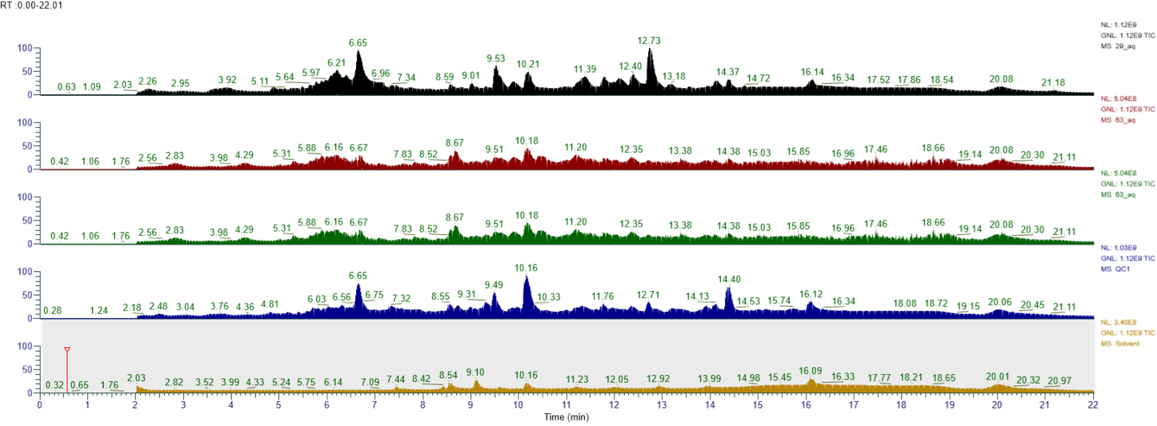

**a**

**b**

**c**

**d**

**e**

**Figure S1** An example of total ion chromatogram of samples from the three groups, QC and the solvent runs; a) sample form the healthy group; b) sample from the ulcerative colitis patient; c) Sample from Crhon’s disease patient; d) mix from all the samples as quality control- QC; e) sample from the solvents as negative control.

**Figure S2** MS2 spectra for the chromatogram peaks shown in figure 9; a) QC Rt 5.57min; b) Stander after five days at Rt 5.64min; c) Standard after five days at Rt 7.79 min; d) standartd at Rt 7.66 without expsure to oxigen.



**c**

**b**

**a**

**d**

**Figure S3** Chromatogram of the QC and the standard; a) The QC chromatogram - the peak shown is for m/z 593.3334;  
b) The standard after 5 days is to be exposed to light and oxygen; c) The standard is directly from the manufacturer’s vail without exposure to oxygen and light.



**c**

**b**

**a**

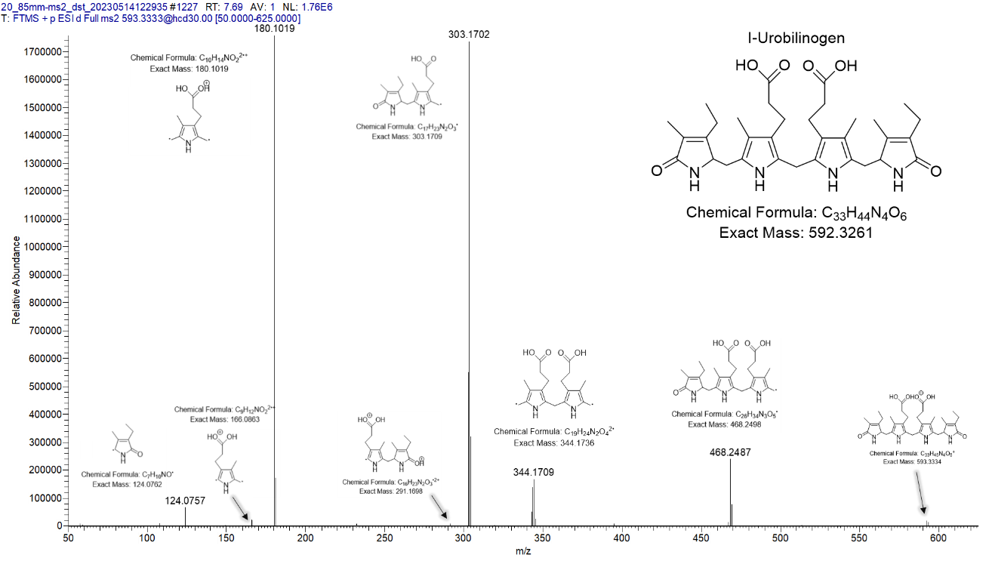

**Figure S4** Identification of all fragment peaks accompanying the parent compound with m/z 593.3332.   
The detection was done manually and strengthened by SIRIUS prediction.

